Task 9: Extended Response

Comparison of Electric and Traditional Cars VALIDATION

Name: _______________
Teacher: ______________
Mark: ___/25
Comment: __________________ _____________________________________________________________________________

Assessment type: Extended Response

Conditions

3 periods of research

1 period of validation-Friday 12th of August

Task weighting

10% of the school mark for this pair of units
6% for Assignment
4% for Validation

Below are 3 questions about conventional vehicles.
- a) What primary reaction causes convention cars to move?
_________________________________________________________(1 mark)
b) What energy transformation happens during this reaction?
_________________________________________________________(2 marks)
- Describe two impacts conventional cars have on the environment (this could include its manufacture, use or disposal).
Impact 1- _________________________________________________________________________________________________________________________________________________________________________________________________________________________________________________________(2 marks)
Impact 2- _________________________________________________________________________________________________________________________________________________________________________________________________________________________________________________________(2 marks)
- One of the pro’s often quoted for conventional cars is the cheaper purchase cost. Explain why this is:
_________________________________________________________________________________________________________________________________________________________________________________________________________________________________________________________(2 marks)
Below are 3 questions about electric vehicles.
- Where is the energy stored in an electric vehicle?
_________________________________________________________(1 mark)
- Describe one impact electric vehicles has on the environment (this could include its manufacture, use or disposal).
_________________________________________________________________________________________________________________________________________________________________________________________________________________________________________________________(2 marks)

- Describe one con, other than purchase cost, to consider when buying an electric vehicle.
_________________________________________________________________________________________________________________________________________________________________________________________________________________________________________________________(2 marks)

The following questions refer to this graphic below:
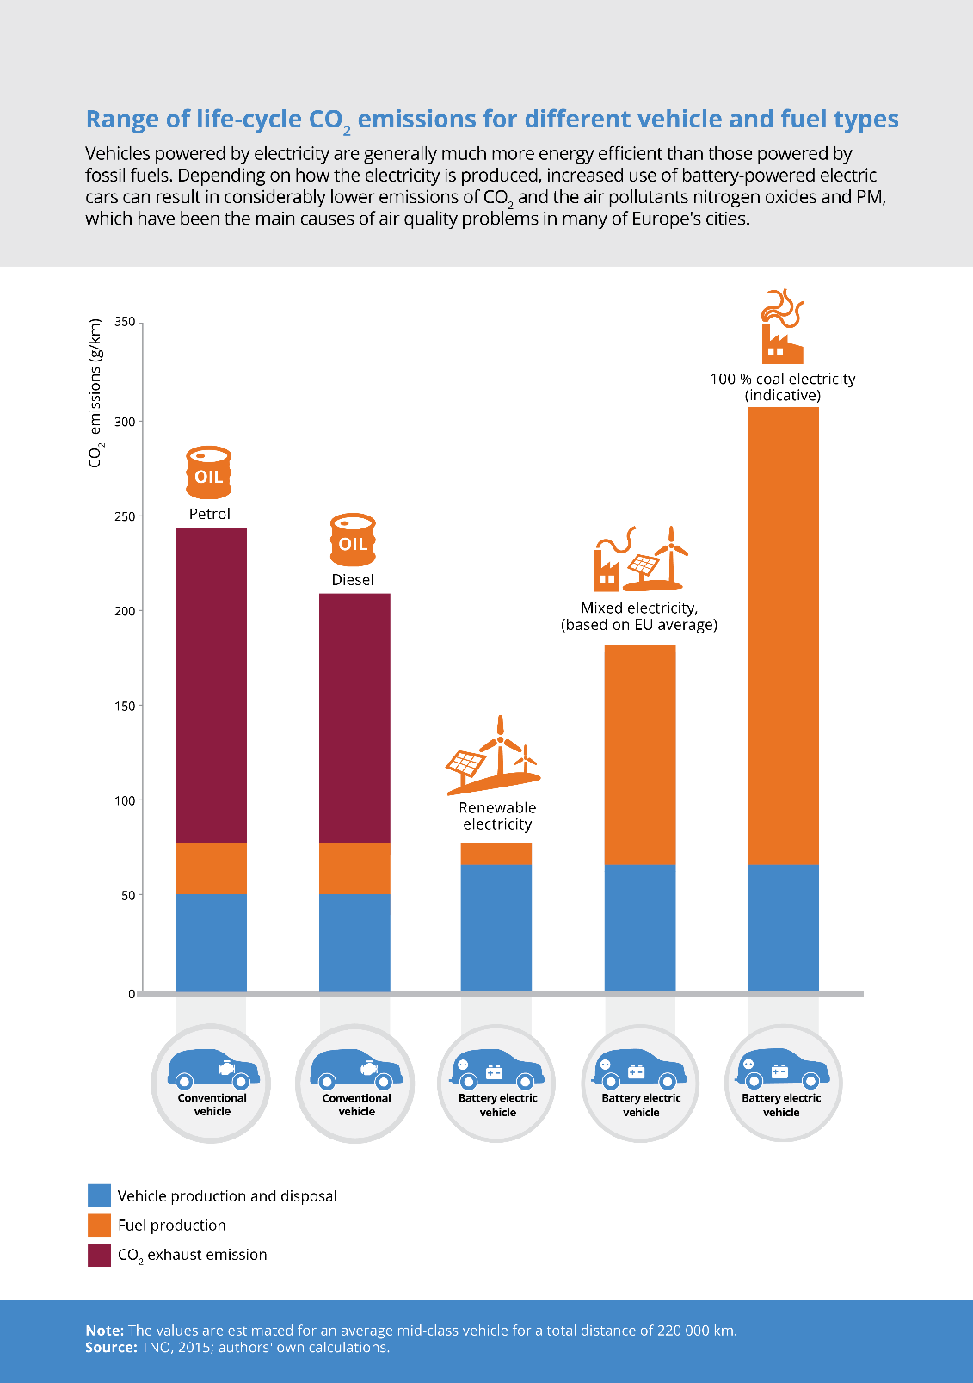

- If you drive a conventional diesel vehicle, what are your total CO₂ emissions in g/km.
_________________________________________________________(1 mark)
- If you drive conventional petrol vehicle, where do most of your CO₂ emissions come from?
_________________________________________________________(1 mark)
- Your friend looked at the graphic above and said “obviously electric cars are worse for the environment. Look at the last column!”. Are they are correct? Use values from the graphic to support your answer.
___________________________________________________________________________________________________________________________________________________________________________________________________________________________________________________________________________________________________________________________
______________________________________________________________________________________________________________________________________________________________________________________(4 marks)
- Give one reason for the difference in emissions between conventional and electric vehicles vehicle production and disposal.
_______________________________________________________________________________________________________________________________________________________________________________________(1 mark)
Use both the graphic and the knowledge you gained from writing your brochure to answer the last question.
- What type of car, electric or conventional, would you purchase for yourself? Provide at least 3 reasons for your answer.
________________________________________________________________________________________________________________________________________________________________________________________________________________________________________________________________________________________________________________________________________________________________________________________________________________________________________________________________________________________________________________________________________________________________________________(4 marks)

